# 

# **INDEX**

| **Sr. No** | **Assignment Title** | **Date** | **Page No** |
| --- | --- | --- | --- |
| 1 | Write a program to find occurrence of any specific word | 08-09-2022 | 3-7 |
| 2 | Write a program to find average word length. | 10-08-2022 | 8-11 |
| 3 | Encrypt the email ids | 23-08-2022 | 12-14 |
| 4 | Multiple file input demo assignment | 29-08-2022 | 15-19 |
| 5 | Web Log Analysis - partitioner demo assignment  I. Odd roll no  II. Even roll No | 30-08-2022 | 20-34 |
| 6 | Partitioner Demo - Cust dataset | 02-09-2022 | 35-41 |
| 7 | Government Crime Assignment - Pig | 08-09-2022 | 42-46 |

# 

# 

# 

# 

# 

# 

# 

# 

# 

# 

# 

# 

# **Assignment : 01**

# 

# **Write a program to find occurrence of any specific word**

**Code:**

import java.io.IOException;

import org.apache.hadoop.fs.Path;

import org.apache.hadoop.io.IntWritable;

import org.apache.hadoop.io.Text;

import org.apache.hadoop.mapreduce.lib.input.FileInputFormat;

import org.apache.hadoop.mapreduce.lib.output.FileOutputFormat;

import org.apache.hadoop.mapreduce.Job;

import org.apache.hadoop.io.LongWritable;

import org.apache.hadoop.mapreduce.Mapper;

import org.apache.hadoop.mapreduce.Reducer;

public class Count {

public static class WordMapper extends Mapper<LongWritable,Text,Text,IntWritable>{

@Override

public void map(LongWritable key, Text value, Context context)

throws IOException, InterruptedException{

String line = value.toString();

String find = "big";

for (String word : line.split("\\W+")){

if(find.equals(word.toLowerCase())){

context.write(new Text(find), new IntWritable(1));

}

}

}

}

public static class SumReducer extends Reducer<Text, IntWritable, Text, IntWritable>{

@Override

public void reduce(Text key, Iterable<IntWritable> values, Context context) throws IOException, InterruptedException{

int wordCount = 0;

for (IntWritable value: values){

wordCount += value.get();

}

context.write(key, new IntWritable(wordCount));

}

}

public static void main(String[] args) throws Exception{

if(args.length != 2){

System.out.printf("Usage: WordCount <input dir> <output dir>\n");

System.exit(-1);

}

Job job = new Job();

job.setJarByClass(Count.class);g

job.setJobName("WordCount");

FileInputFormat.setInputPaths(job, new Path(args[0]));

FileOutputFormat.setOutputPath(job, new Path(args[1]));

job.setMapperClass(WordMapper.class);

job.setReducerClass(SumReducer.class);

job.setOutputKeyClass(Text.class);

job.setOutputValueClass(IntWritable.class);

boolean success = job.waitForCompletion(true);

System.exit(success ? 0 : 1);

}

}

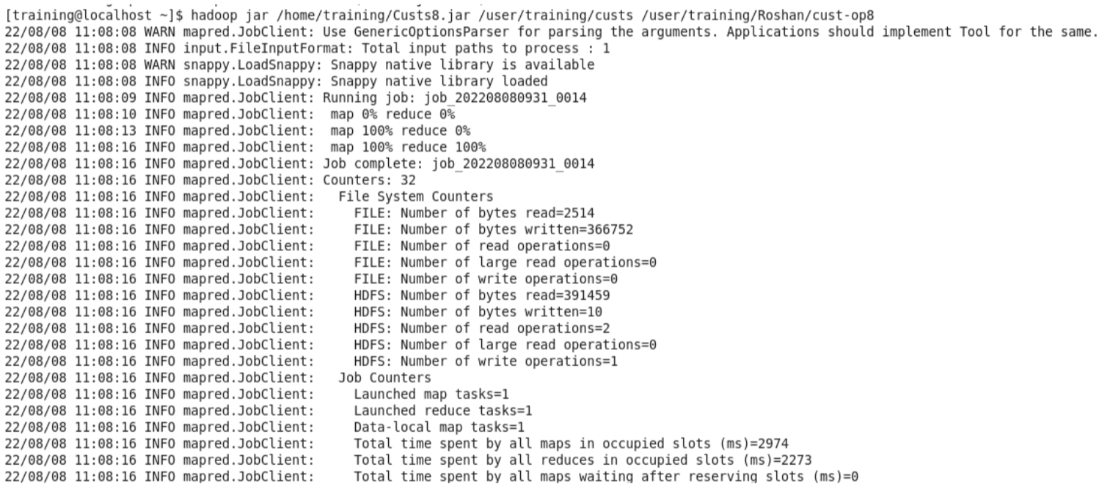

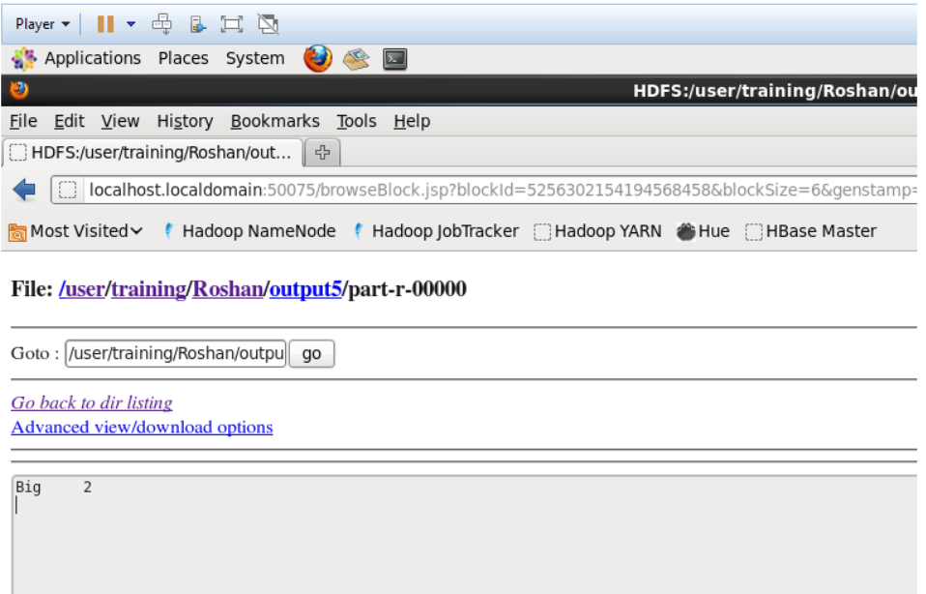

**Count of specific profession**

**Code:**

import java.io.IOException;

import org.apache.hadoop.fs.Path;

import org.apache.hadoop.io.IntWritable;

import org.apache.hadoop.io.Text;

import org.apache.hadoop.mapreduce.lib.input.FileInputFormat;

import org.apache.hadoop.mapreduce.lib.output.FileOutputFormat;

import org.apache.hadoop.mapreduce.Job;

import org.apache.hadoop.io.LongWritable;

import org.apache.hadoop.mapreduce.Mapper;

import org.apache.hadoop.mapreduce.Reducer;

public class Cust {

public static class WordMapper extends Mapper<LongWritable,Text,Text,IntWritable>{

@Override

public void map(LongWritable key, Text value, Context context)

throws IOException, InterruptedException{

String line = value.toString();

String find = "Pilot";

for (String word : line.split(",")){

if(find.equals(word)){

context.write(new Text(find), new IntWritable(1));

}

}

}

}

public static class SumReducer extends Reducer<Text, IntWritable, Text, IntWritable>{

@Override

public void reduce(Text key, Iterable<IntWritable> values, Context context) throws IOException, InterruptedException{

int wordCount = 0;

for (IntWritable value: values){

wordCount += value.get();

}

context.write(key, new IntWritable(wordCount));

}

}

public static void main(String[] args) throws Exception{

if(args.length != 2){

System.out.printf("Usage: WordCount <input dir> <output dir>\n");

System.exit(-1);

}

Job job = new Job();

job.setJarByClass(Cust.class);

job.setJobName("Custs");

FileInputFormat.setInputPaths(job, new Path(args[0]));

FileOutputFormat.setOutputPath(job, new Path(args[1]));

job.setMapperClass(WordMapper.class);

job.setReducerClass(SumReducer.class);

job.setOutputKeyClass(Text.class);

job.setOutputValueClass(IntWritable.class);

boolean success = job.waitForCompletion(true);

System.exit(success ? 0 : 1);

}

}

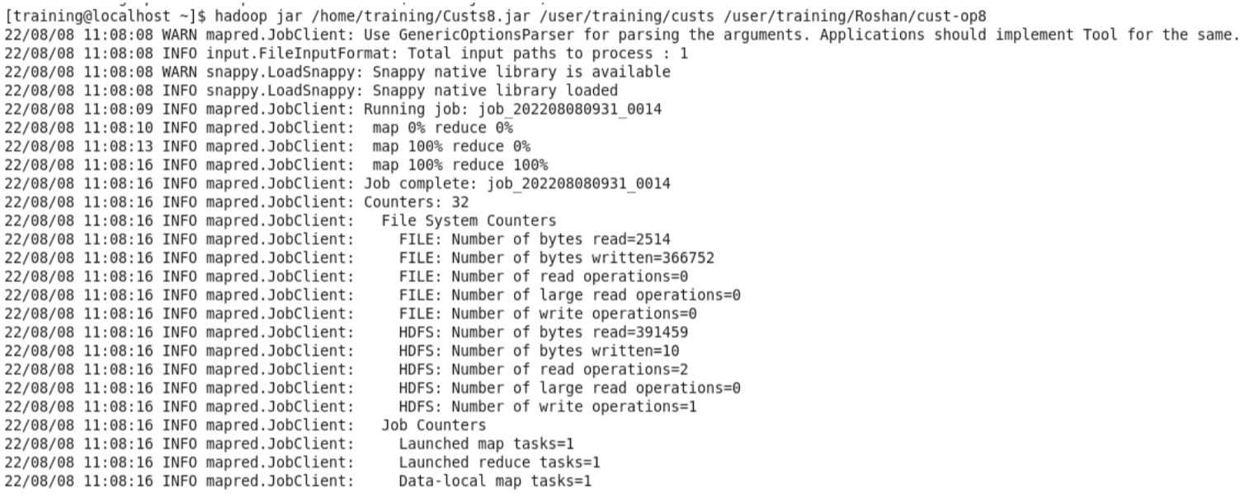

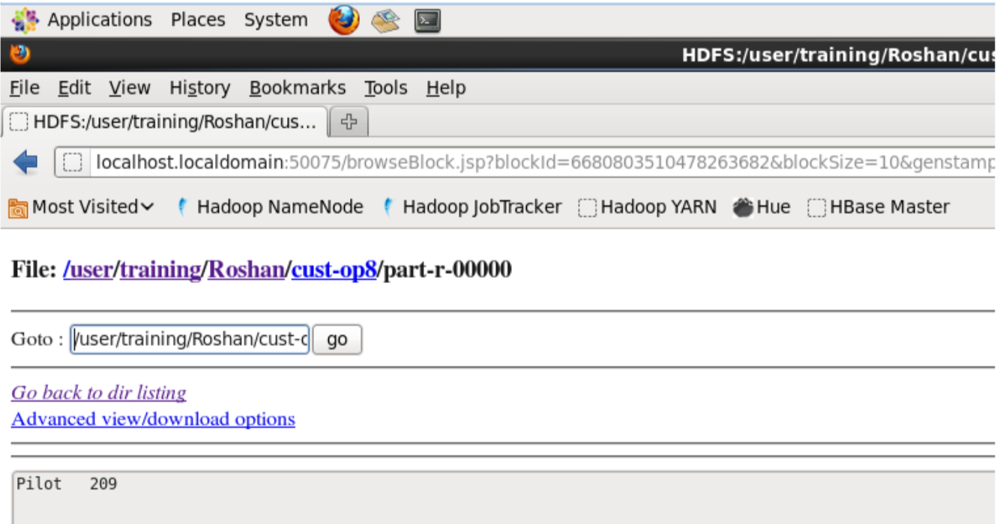

# **Assignment : 02**

# 

# **Write a program to find average word length.**

**Code:**

import java.io.IOException;

import org.apache.hadoop.fs.Path;

import org.apache.hadoop.io.FloatWritable;

import org.apache.hadoop.io.Text;

import org.apache.hadoop.mapreduce.lib.input.FileInputFormat;

import org.apache.hadoop.mapreduce.lib.output.FileOutputFormat;

import org.apache.hadoop.mapreduce.Job;

import org.apache.hadoop.io.LongWritable;

import org.apache.hadoop.mapreduce.Mapper;

import org.apache.hadoop.mapreduce.Reducer;

public class Average {

public static class WordMapper extends Mapper <LongWritable, Text, Text, FloatWritable>

{

@Override

public void map(LongWritable key,Text value, Context context)

throws IOException, InterruptedException{

Text firstLetter = new Text();

FloatWritable wordLength = new FloatWritable();

String line = value.toString().toLowerCase();

for(String word:line.split(" ")){

if (word.length() > 0) {

firstLetter.set(String.valueOf(word.charAt(0)));

wordLength.set(word.length());

context.write(firstLetter, wordLength);

}

}

}

}

public static class SumReducer extends Reducer<Text,FloatWritable,Text,FloatWritable>{

public void reduce(Text key,Iterable<FloatWritable>values,Context context)

throws IOException,InterruptedException{

int sum =0;

int count =0;

int Average =0;

for(FloatWritable val:values) {

sum += val.get();

count = count+1;

}

Average = sum/count;

context.write(key,new FloatWritable(Average));

}

}

public static void main(String[] args) throws Exception{

if(args.length != 2){

System.out.printf(

"Usage: WordCount <input dir> <output dir> \n");

System.exit(-1);

}

Job job = new Job();

job.setJarByClass(Average.class);

job.setJobName("Word Count");

FileInputFormat.setInputPaths(job, new Path(args[0]));

FileOutputFormat.setOutputPath(job, new Path(args[1]));

job.setMapperClass(WordMapper.class);

job.setReducerClass(SumReducer.class);

job.setOutputKeyClass(Text.class);

job.setOutputValueClass(FloatWritable.class);

boolean success = job.waitForCompletion(true);

System.exit(success ? 0 :1);

}

}

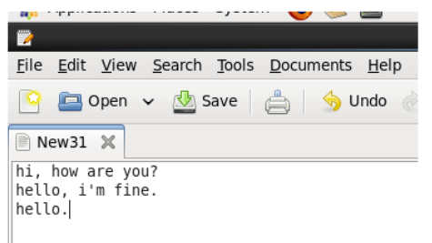

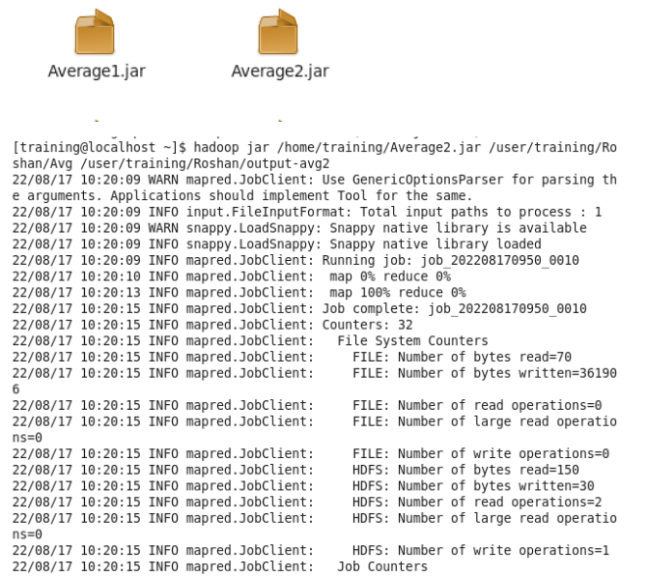

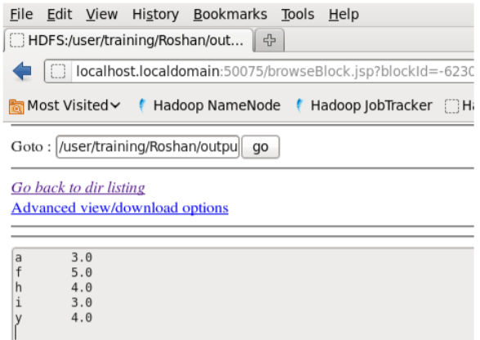

# **Assignment : 03**

# 

# **Encrypt the email ids**

**use "Only mapper" design pattern**

import java.io.IOException;

import org.apache.hadoop.conf.Configuration;

import org.apache.hadoop.fs.Path;

import org.apache.hadoop.io.Text;

import org.apache.hadoop.mapreduce.Job;

import org.apache.hadoop.mapreduce.Mapper;

import org.apache.hadoop.io.LongWritable;

import org.apache.hadoop.mapreduce.lib.input.FileInputFormat;

import org.apache.hadoop.mapreduce.lib.output.FileOutputFormat;

import org.apache.hadoop.util.GenericOptionsParser;

public class Encry {

public static class MapForEncryption extends Mapper<LongWritable, Text, Text, Text>

{

public void map(LongWritable key, Text Value, Context con)throws IOException, InterruptedException

{

String line=Value.toString();

int encry; //created a object which will store the encrypted character

String mask = ""; //mask object initialized with null value which will store the actual output text

for(int i=0;i<line.length();i++) //for loop which will iterate through line

{

char c = line.charAt(i); //store each character at index i

encry = 4 + (int)c; //increment the alphabet by 4

c = (char)encry; //type cast encry into char

mask += c; //store the final text in mask

}

//String line1 = line.replace("||",",");

Text outputKey = new Text(mask);

Text outputValue = new Text("");

con.write(outputKey,outputValue);

}

}

public static void main(String[] args) throws Exception{

Configuration c = new Configuration();

String[] files = new GenericOptionsParser(c,args).getRemainingArgs();

Path input = new Path(files[0]);

Path output = new Path(files[1]);

Job j = new Job(c,"FormatEmpFile");

j.setJarByClass(Encry.class);

j.setJobName("");

j.setMapperClass(MapForEncryption.class);

j.setNumReduceTasks(0);

j.setMapOutputKeyClass(Text.class);

j.setMapOutputValueClass(Text.class);

FileInputFormat.addInputPath(j,input);

FileOutputFormat.setOutputPath(j,output);

System.exit(j.waitForCompletion(true)? 0:1);

}}

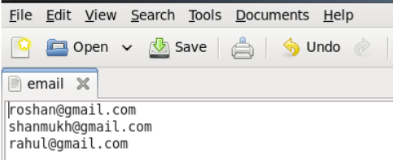

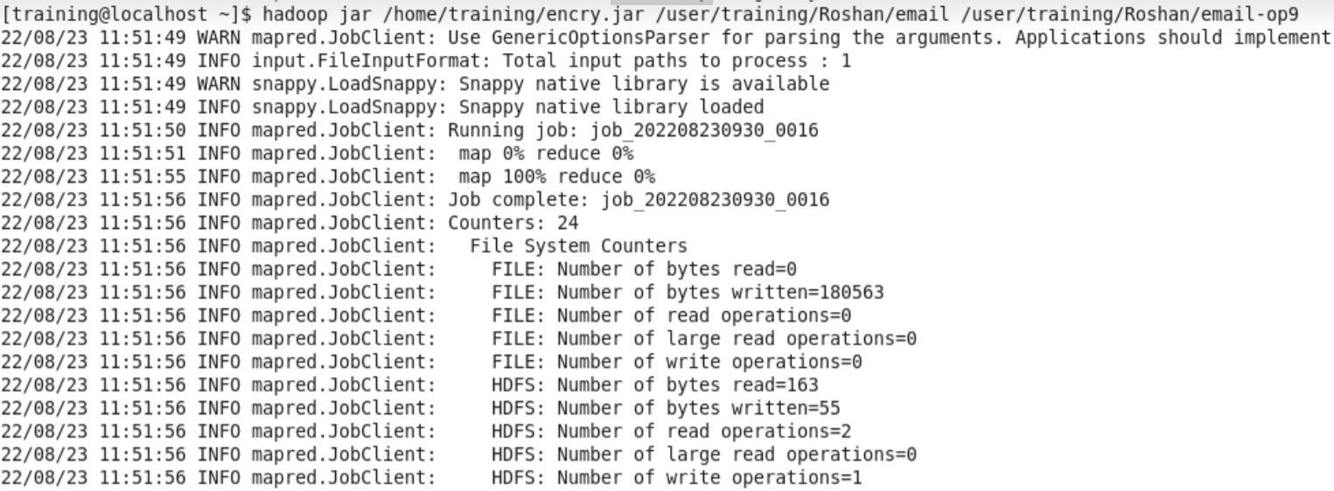

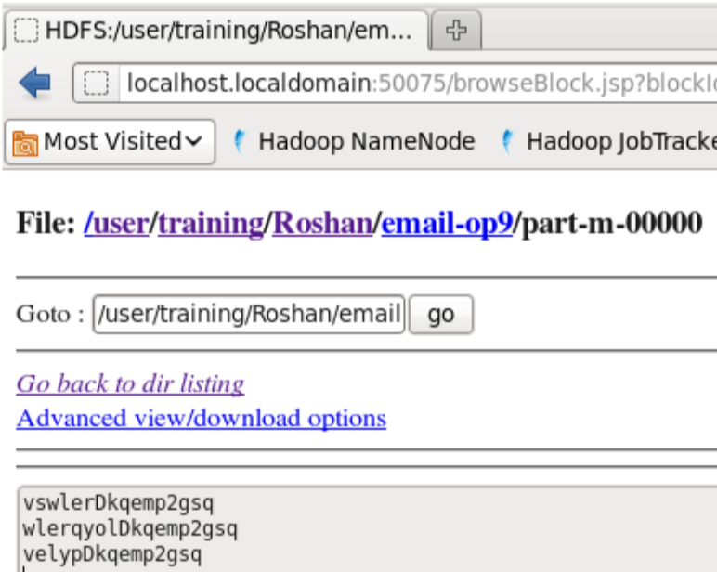

# **Assignment : 04**

# Multiple file input demo assignment

**Create 2 or 3 input files on your own , in which the data is present in different formats. Write a program to process these files using different map classes and perform any one aggregate function like sum, max, min etc. on it.**

import java.io.IOException;

import org.apache.hadoop.conf.Configuration;

import org.apache.hadoop.fs.Path;

import org.apache.hadoop.io.IntWritable;

import org.apache.hadoop.io.LongWritable;

import org.apache.hadoop.io.Text;

import org.apache.hadoop.mapreduce.Job;

import org.apache.hadoop.mapreduce.Mapper;

import org.apache.hadoop.mapreduce.Reducer;

import org.apache.hadoop.mapreduce.lib.input.MultipleInputs;

import org.apache.hadoop.mapreduce.lib.input.TextInputFormat;

import org.apache.hadoop.mapreduce.lib.output.FileOutputFormat;

import org.apache.hadoop.util.GenericOptionsParser;

public class MultipleInputFiles {

public static class map1 extends Mapper<LongWritable,Text,Text,IntWritable>

{

public void map(LongWritable key, Text value, Context con) throws IOException, InterruptedException

{

String line = value.toString();

String[] line1 = line.split(",");

String name = line1[0];

Text outputKey = new Text(name);

int cost = Integer.parseInt(line1[2]);

IntWritable outputValue = new IntWritable(cost);

con.write(outputKey, outputValue);

}

}

public static class Map2 extends Mapper<LongWritable, Text, Text, IntWritable>

{

public void map(LongWritable key, Text value, Context con) throws IOException, InterruptedException

{

String line = value.toString();

String[] line1 = line.split(",");

String name = line1[0];

Text outputKey = new Text(name);

int cost = Integer.parseInt(line1[2]);

IntWritable outputValue = new IntWritable(cost);

con.write(outputKey, outputValue);

}

}

public static class Map3 extends Mapper<LongWritable, Text, Text, IntWritable>

{

public void map(LongWritable key, Text value, Context con) throws IOException, InterruptedException

{

String line = value.toString();

String[] line1 = line.split(",");

String name = line1[1];

Text outputKey = new Text(name);

int cost = Integer.parseInt(line1[3]);

IntWritable outputValue = new IntWritable(cost);

con.write(outputKey, outputValue);

}

}

public static class Red extends Reducer<Text, IntWritable, Text,IntWritable>

{

public void reduce(Text name, Iterable<IntWritable>total_cost, Context con) throws IOException, InterruptedException

{

//to get the sum of cost

// int sum = 0;

// for(IntWritable value : total_cost){

// sum += value.get();

//}

//to get the max cost

int max = 0;

for (IntWritable value : total_cost) {

if (value.get() > max) {

max = value.get();

}

}

con.write(name,new IntWritable(max));

}

}

public static void main(String[] args) throws Exception{

Configuration c = new Configuration();

GenericOptionsParser parser = new GenericOptionsParser(c,args);

String[] files = parser.getRemainingArgs();

Path p1 = new Path(files[0]);

Path p2 = new Path(files[1]);

Path p3 = new Path(files[2]);

Path p4 = new Path(files[3]);

Job j = new Job(c,"multiple");

j.setJarByClass(MultipleInputFiles.class);

j.setMapperClass(map1.class);

j.setMapperClass(Map2.class);

j.setReducerClass(Red.class);

j.setOutputKeyClass(Text.class);

j.setOutputValueClass(IntWritable.class);

MultipleInputs.addInputPath(j,p1,TextInputFormat.class,map1.class);

MultipleInputs.addInputPath(j, p2, TextInputFormat.class,Map2.class);

MultipleInputs.addInputPath(j, p3, TextInputFormat.class,Map3.class);

FileOutputFormat.setOutputPath(j,p4);

System.exit(j.waitForCompletion(true)?0:1);

}

}

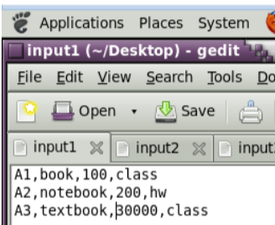

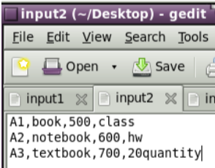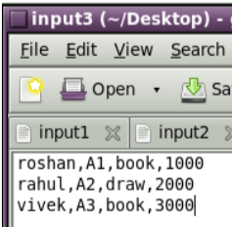

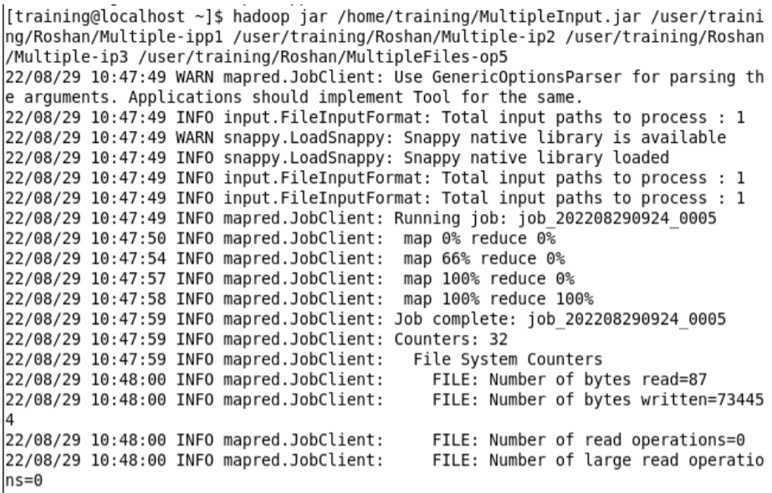

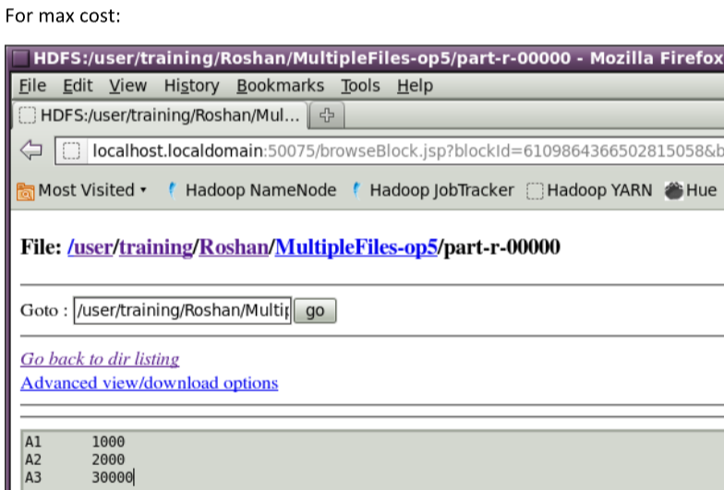

# **Assignment : 05**

# 

# **Web Log Analysis - partitioner demo assignment**

Odd

Write a MapReduce program to find profession-wise (choose any 5 professions) of customer count from the "cust" dataset.

Code:

**import** java.io.*;

**import** org.apache.hadoop.io.*;

**import** org.apache.hadoop.mapreduce.*;

**import** org.apache.hadoop.conf.*;

**import** org.apache.hadoop.fs.*;

**import** org.apache.hadoop.mapreduce.lib.input.*;

**import** org.apache.hadoop.mapreduce.lib.output.*;

**import** org.apache.hadoop.util.*;

**public** **class** part **extends** Configured **implements** Tool{

//map class

**public** **static** **class** Map **extends** Mapper<LongWritable, Text, Text, IntWritable> {

@Override **public** **void** map (LongWritable key, Text value, Context context)

**throws** IOException, InterruptedException {

String line = value.toString();

String[] date =line.split("/");

String month=date[1];

context.write(**new** Text (month), **new** IntWritable (1));

}

}

//Reducer class

**public** **static** **class** SumReducer **extends** Reducer<Text,IntWritable,Text,IntWritable> {

@Override **public** **void** reduce(Text name, Iterable<IntWritable>values,Context context)

**throws** IOException, InterruptedException {

**int** Count = 0;

**for** (IntWritable value : values) {

Count += value.get();

}

context.write(name, **new** IntWritable (Count));

}

}

//Partitioner class

**public** **static** **class** CaderPartitioner **extends** Partitioner<Text,IntWritable>{

**public** **int** getPartition (Text name,IntWritable value,**int** numReduceTasks)

{

**if** (name.toString().equals("Jan"))

{

**return** 1 ;

}

**else** **if** (name.toString().equals("Feb"))

{

**return** 2;

}

**else** **if** (name.toString().equals("Mar") )

{

**return** 3;

}

**else** **if** (name.toString().equals("Apr") )

{

**return** 4; }

**else** **if** (name.toString().equals("May") )

{

**return** 5;

}

**else** **if** (name.toString().equals("Jun") )

{

**return** 6;

}

**else** **if** (name.toString().equals("Jul") )

{

**return** 7;

}

**else** **if** (name.toString().equals("Aug"))

{

**return** 8;

}

**else** **if** (name.toString().equals("Sep"))

{

**return** 9;

}

**else** **if** (name.toString().equals("Oct"))

{

**return** 10;

}

**else** **if** (name.toString().equals("Nov"))

{

**return** 11;

}

**else** **if** (name.toString().equals("Dec"))

{

**return** 12;

}

**else**{

**return** 0;

}

}

}

**public** **static** **void** main(String[] arg) **throws** Exception{

// **TODO** Auto-generated method stub

**int** res=ToolRunner.*run*(**new** Configuration(),**new** part(), arg);

System.*exit*(0);

}

@Override

**public** **int** run(String[] arg) **throws** Exception {

// **TODO** Auto-generated method stub

Configuration conf = getConf() ;

Job job = **new** Job(conf,"part");

job.setJarByClass(part.**class**);

FileInputFormat.*setInputPaths*(job,**new** Path(arg[0]));

FileOutputFormat.*setOutputPath*(job,**new** Path(arg[1]));

job.setMapperClass(Map.**class**);

job.setMapOutputKeyClass(Text.**class**) ;

job.setMapOutputValueClass(IntWritable.**class**) ;

// set partitioner statement

job.setPartitionerClass(CaderPartitioner.**class**) ;

job.setReducerClass(SumReducer.**class**);

job.setNumReduceTasks(13) ;

job.setInputFormatClass (TextInputFormat.**class**);

job.setOutputFormatClass(TextOutputFormat.**class**);

job.setOutputKeyClass(Text.**class**);

job.setOutputValueClass(Text.**class**);

System.*exit*(job.waitForCompletion(**true**)? 0:1);

**return** 0 ;

}

}

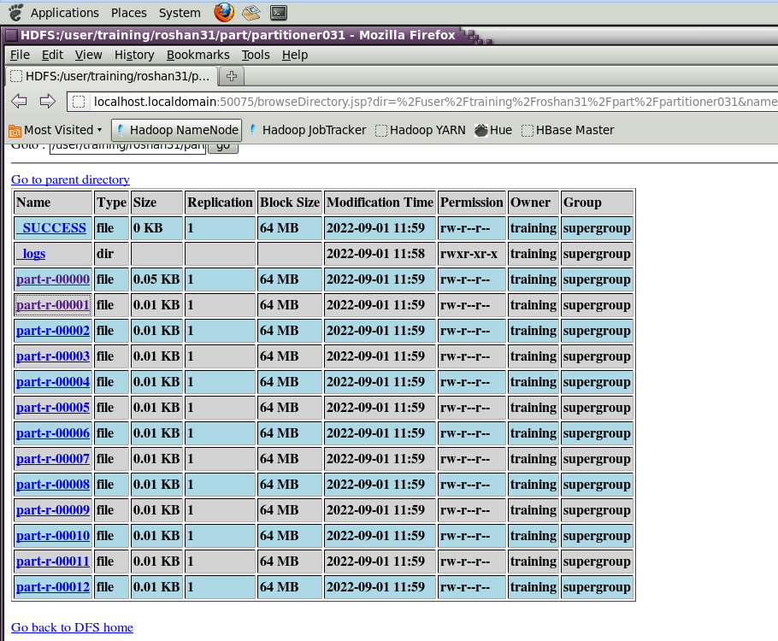

Even

Write a MapReduce program to find age group-wise (20 to 30,31 to 45, 46 to 60, >61) of customer count from the "cust" dataset.

Code:

**import** java.io.*;

**import** org.apache.hadoop.io.*;

**import** org.apache.hadoop.mapreduce.*;

**import** org.apache.hadoop.conf.*;

**import** org.apache.hadoop.fs.*;

**import** org.apache.hadoop.mapreduce.Mapper.Context;

**import** org.apache.hadoop.mapreduce.lib.input.*;

**import** org.apache.hadoop.mapreduce.lib.output.*;

**import** org.apache.hadoop.util.*;

**public** **class** age **extends** Configured **implements** Tool {

**public** **static** **class** Map **extends** Mapper<LongWritable, Text, Text, Text> {

@Override **public** **void** map (LongWritable key, Text value, Context context)

**throws** IOException, InterruptedException {

String line = value.toString();

String[] cust =line.split(",");

String age=cust[3];

context.write(**new** Text (age), **new** Text(value));

}

}

**public** **static** **class** CodeReducer **extends** Reducer<Text, Text, Text, IntWritable>{

@Override

**public** **void** reduce(Text name, Iterable<Text> values, Context context) **throws** IOException, InterruptedException{

**int** Count = 0;

**for** (Text value: values){

Count += 1;

}

context.write(name, **new** IntWritable(Count));

}

}

**public** **static** **class** CaderPartitioner **extends** Partitioner<Text,Text>{

**public** **int** getPartition (Text name,Text value,**int** numReduceTasks)

{

String line = value.toString();

String[] cust =line.split(",");

**int** age=Integer.*parseInt*(cust[3]);

**if** (age>=20 && age<=30)

{

**return** 1 ;

}

**else** **if** (age>=31 && age<=45)

{

**return** 2;

}

**else** **if** (age>=46 && age<=60 )

{

**return** 3;

}

**else** **if** (age>=61 )

{

**return** 4;

}

**else**

{

**return** 0;

}

}

}

**public** **int** run(String[] arg) **throws** Exception {

// **TODO** Auto-generated method stub

Configuration conf = getConf() ;

Job job = **new** Job(conf,"cust");

job.setJarByClass(age.**class**);

FileInputFormat.*setInputPaths*(job,**new** Path(arg[0]));

FileOutputFormat.*setOutputPath*(job,**new** Path(arg[1]));

job.setMapperClass(Map.**class**);

job.setMapOutputKeyClass(Text.**class**) ;

job.setMapOutputValueClass(Text.**class**) ;

job.setPartitionerClass(CaderPartitioner.**class**) ;

job.setReducerClass(CodeReducer.**class**);

job.setNumReduceTasks(6) ;

job.setInputFormatClass (TextInputFormat.**class**);

job.setOutputFormatClass(TextOutputFormat.**class**);

job.setOutputKeyClass(Text.**class**);

job.setOutputValueClass(Text.**class**);

System.*exit*(job.waitForCompletion(**true**)? 0:1);

**return** 0 ;

}

**public** **static** **void** main(String[] arg) **throws** Exception{

// **TODO** Auto-generated method stub

**int** res=ToolRunner.*run*(**new** Configuration(),**new** age(), arg);

System.*exit*(0);

}

}

# **Assignment : 06**

# 

# **Partitioner Demo - Cust dataset**

**Code:**

**import** java.io.*;

**import** org.apache.hadoop.io.*;

**import** org.apache.hadoop.mapreduce.*;

**import** org.apache.hadoop.conf.*;

**import** org.apache.hadoop.fs.*;

**import** org.apache.hadoop.mapreduce.Mapper.Context;

**import** org.apache.hadoop.mapreduce.lib.input.*;

**import** org.apache.hadoop.mapreduce.lib.output.*;

**import** org.apache.hadoop.util.*;

**public** **class** cust **extends** Configured **implements** Tool{

**public** **static** **class** Map **extends** Mapper<LongWritable, Text, Text, IntWritable> {

@Override **public** **void** map (LongWritable key, Text value, Context context)

**throws** IOException, InterruptedException {

String line = value.toString();

String[] cust =line.split(",",-3);

String name=cust[4];

context.write(**new** Text (name), **new** IntWritable (1));

}

}

**public** **static** **class** CodeReducer **extends** Reducer<Text, IntWritable, Text, IntWritable>{

@Override

**public** **void** reduce(Text name, Iterable<IntWritable> values, Context context) **throws** IOException, InterruptedException{

**int** Count = 0;

**for** (IntWritable value: values){

Count += value.get();

}

context.write(name, **new** IntWritable(Count));

}

}

**public** **static** **class** CaderPartitioner **extends** Partitioner<Text,IntWritable>{

**public** **int** getPartition (Text name,IntWritable value,**int** numReduceTasks)

{

**if** (name.toString().equals("Pilot"))

{

**return** 1 ;

}

**else** **if** (name.toString().equals("Teacher"))

{

**return** 2;

}

**else** **if** (name.toString().equals("Lawyer") )

{

**return** 3;

}

**else** **if** (name.toString().equals("Pharmacist") )

{

**return** 4; }

**else** **if** (name.toString().equals("Carpenter") )

{

**return** 5;

}

**else**{

**return** 0;

}

}

}

**public** **static** **void** main(String[] arg) **throws** Exception{

// **TODO** Auto-generated method stub

**int** res=ToolRunner.*run*(**new** Configuration(),**new** cust(), arg);

System.*exit*(0);

}

**public** **int** run(String[] arg) **throws** Exception {

// **TODO** Auto-generated method stub

Configuration conf = getConf() ;

Job job = **new** Job(conf,"cust");

job.setJarByClass(cust.**class**);

FileInputFormat.*setInputPaths*(job,**new** Path(arg[0]));

FileOutputFormat.*setOutputPath*(job,**new** Path(arg[1]));

job.setMapperClass(Map.**class**);

job.setMapOutputKeyClass(Text.**class**) ;

job.setMapOutputValueClass(IntWritable.**class**) ;

// set partitioner statement

job.setPartitionerClass(CaderPartitioner.**class**) ;

job.setReducerClass(CodeReducer.**class**);

job.setNumReduceTasks(6) ;

job.setInputFormatClass (TextInputFormat.**class**);

job.setOutputFormatClass(TextOutputFormat.**class**);

job.setOutputKeyClass(Text.**class**);

job.setOutputValueClass(Text.**class**);

System.*exit*(job.waitForCompletion(**true**)? 0:1);

**return** 0 ;

}

}

# **Assignment : 07**

**Government Crime Assignment - Pig**

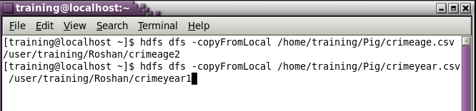



## **1.To find the total number of crimes which occurred in all the states in the year 2006.**

crimeyear7 = load '/user/training/Roshan/crimeyear2' using PigStorage(',') AS (STATE:chararray, CRIMEHEAD:chararray, one:int, two:int, three:int, four:int, five:int, six:int, seven:int, eight:int, nine:int, ten:int, eleven:int, twelve:int);

G = GROUP crimeyear7 BY STATE;

C = FOREACH G generate group, SUM(crimeyear7.six);

Dump C;

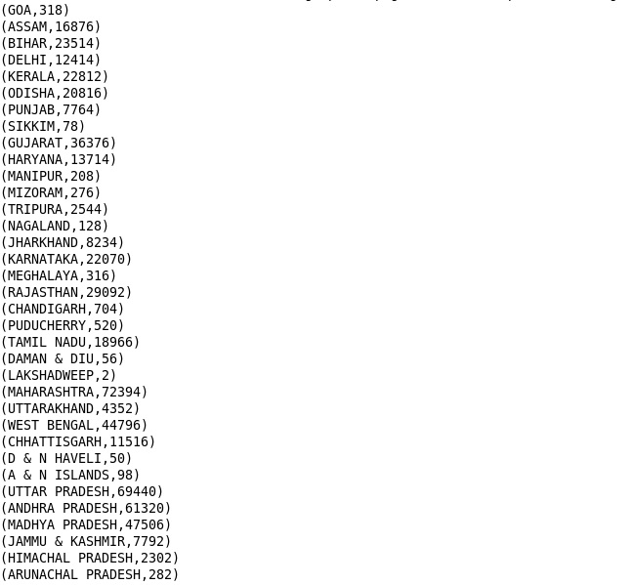

**2. Calculate the number of females (age between 18-30 years) who were victims in different crimes in different states**

crimeage = LOAD '/user/training/Roshan/crimeage' using PigStorage(',') AS (STATE1:chararray, Crimehead1:chararray, Male_Below_18_Years:int, Female_Below_18_Years:int, Male_Between_18_30_Years:int, Female_Between_18_30_Years:int, Male_Between_30_45_Years:int, Female_Between_30_45_Years:int, Male_Between_45_60_Years:int, Female_Between_45_60_Years:int, Male_Above_60_Years:int, Female_Above_60_Years:int, Total_Male:int, Total_Female:int, Grand_Total:int);

G = GROUP crimeage ALL;

C = FOREACH G generate group, SUM(crimeage.Female_Between_18_30_Years);

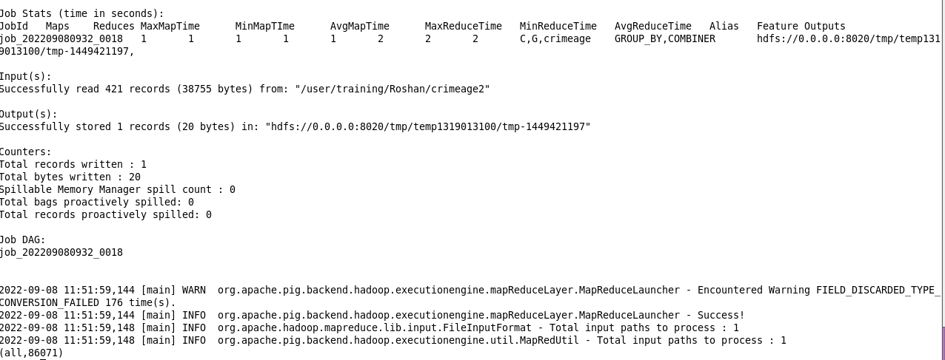

## **3. Which state have highest rape cases across all years.**

crimeyear = LOAD '/user/training/Roshan/crimeyear' using PigStorage(',') AS (STATE:chararray, CRIMEHEAD:chararray, one:int, two:int, three:int, four:int, five:int, six:int, seven:int, eight:int, nine:int, ten:int, eleven:int, twelve:int);

rape_case = filter crimeyear by CRIMEHEAD matches 'RAPE';

g = FOREACH rape_case generate $0,$14;

c = ORDER g by $1 desc;

r = LIMIT c 1;

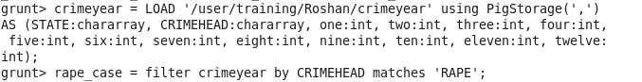

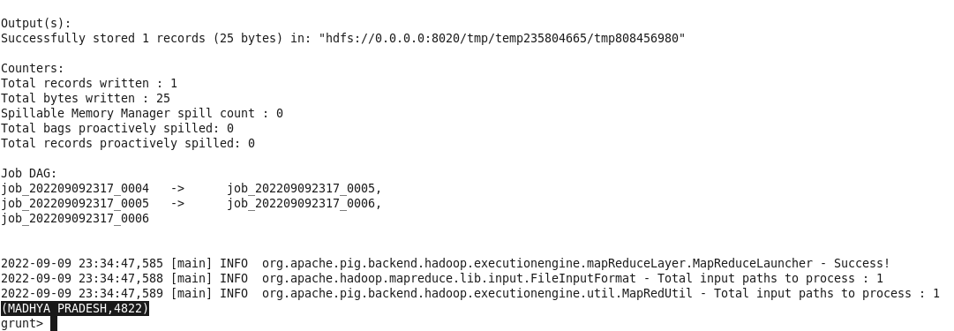

**4. Find crime wise which state has the highest count.**

crimeage = LOAD '/user/training/Roshan/crimeage' using PigStorage(',') AS (STATE1:chararray, Crimehead1:chararray, Male_Below_18_Years:int, Female_Below_18_Years:int, Male_Between_18_30_Years:int, Female_Between_18_30_Years:int, Male_Between_30_45_Years:int, Female_Between_30_45_Years:int, Male_Between_45_60_Years:int, Female_Between_45_60_Years:int, Male_Above_60_Years:int, Female_Above_60_Years:int, Total_Male:int, Total_Female:int, Grand_Total:int);

count = FOREACH crimeage generate $0, $1, $14;

count2 = group count all;

max = foreach count2 generate MAX(count.$2) as cr;

s_count = filter count by $2 == max.cr;

